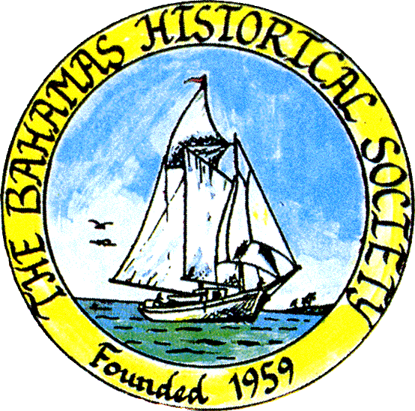
P. O. Box SS-6833
Nassau, N. P.
The Bahamas
 (242) 322-4231
email address: thebahamashistoricalsociety@gmail.com
Website: thebahamashistoricalsociety.org

/242HistoricalSociety
- BahamasHistSociety
Dear Members and Friends,

Living Memory

Living memory in the culture of the Ancient Greeks was seventy years, the limit of past knowledge. Similarly, the West African had a language that distinguished between sasa, the realm of the here and now and zamani, the realm of the ancestors and spirits, going back the biblical three score and ten years.

Remembrance Day reminds us that we are celebrating the sacrifice of our ancestors during World Wars 1 and 2. The poppy is the symbol of our appreciation of the courage and suffering of those ancestors, who sacrificed their life in both world wars.

During World War 2 seventeen men left the Bahamas to work in the munitions factories in Great Britain. Between two and three hundred Bahamians, men and women, served in the armed forces of Britain, Canada and USA. Fourteen men lost their lives in active service. And of course, since then many veterans have died of war wounds or natural causes.

I found this poem in the Bahamas Historical Society Museum that is a dedication to Bahamian Airmen and their part in the Second World War.

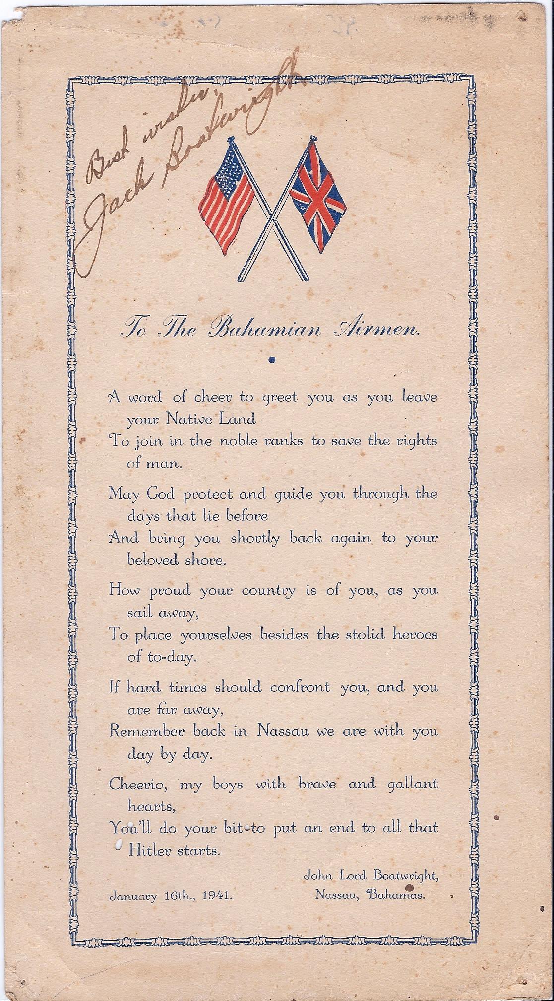

A message from Logos Bookstore:
Logos Bookstore Invites you to join us as we welcome Jim Lawlor for the signing of his latest book "The Bahamas: History and Memoir" on Saturday 16 November 2024 11am - 2pm

The Bahamas: History and Memoir.

At the age of 85 I have almost 56 years of memories and about 42 years of research and writing Bahamian history in my mind and on my computer. In this book I reveal my research for Paul Albury on Harbour Island, Paradise Island and Bliss Carman; demography of black and coloured population for linguistic writings of Anne Lawlor which led to my book From Africa to The Bahamas; research for Arthur Hailey on Lyford Cay; research for Sir Orville Turnquest that highlights material on the Duke of Windsor, the Burma Road Riot and the murder of Sir Harry Oakes not previously covered; research for Dr Lisa Lawlor Feller on The Bahamas as a Maritime Highway which led to several personal articles; my own memories, research and writings for books and articles which include some of my religious writings; some of the research requested of me as President of The Bahamas Historical Society and snippets of Bahamian History highlighted in my Bahamas Historical Society Newsletters. I have also written brief chapters highlighting Bahamian History and The History of Harbour Island. I have also completed a short story that started out as a meditative romantic historical novel set in the early eighteenth century.

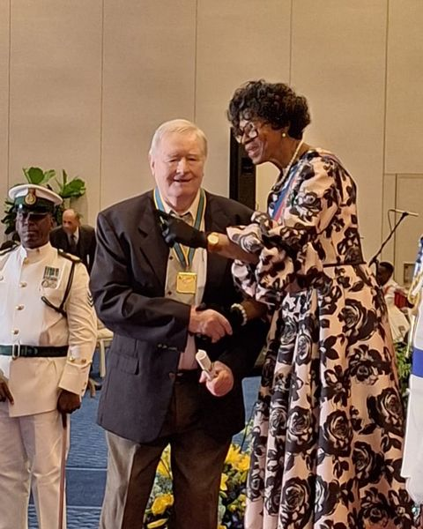

Jim was presented with the National Award: Order of Excellence on National Heroes Day 2024 and became the Honourable James Lawlor, O.E.

The 4th annual Tingsmas market for Sunday December 1 at the National Art Gallery of The Bahamas where vendors set up to sell merch for Christmas. This year will introduce an educational pavilion which features different Bahamian disciplines such as language, bush medicine, straw and junkanoo etc. It's going to be a separate area of the market dedicated to facilitating the different workshops (bush medicine, language, straw, history etc).

One of the areas she wants to feature was Bahamian history. The purpose of the pavilion is to be both educational, engaging and entertaining. She is looking for experts that are interested in creating a unique experience for attendees to interact in the respective disciplines.

The Bahamas Historical Society has agreed to man two tables. Jim Lawlor, daughter Dr Lisa Lawlor Feller, President Andrea Major and Subrenna Higgs will be promoting history and selling books and journals between 12 noon to 4pm.

Please support this worthwhile event.

Kind Regards
Jim Lawlor
Jim Lawlor (Vice President and Corresponding Secretary)

