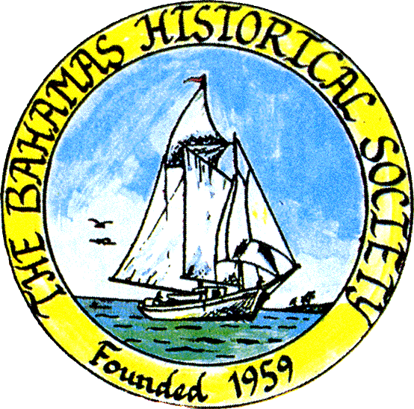
P. O. Box SS-6833
Nassau, N. P.
The Bahamas
 (242) 322-4231
email address: thebahamashistoricalsociety@gmail.com
Website: thebahamashistoricalsociety.org

/242HistoricalSociety
- BahamasHistSociety
Dear Members and Friends,

We are pleased to announce that the Annual General Meeting of The Bahamas Historical Society will take place:

Saturday 29th June 2024 at 10 am. AGM
Place: The Bahamas Historical Society & Museum
Corner of Shirley Street & Elizabeth Avenue
Tel – 322-4231 or 424-3107

Parking kindly allowed by CIBC First Caribbean Bank Shirley Street. Enter lot on Shirley Street.

Members and friends can also participate via Zoom:

Type zoom.com or click the link below to Join Zoom Meeting
https://us06web.zoom.us/j/83952739563?pwd=eThSSHNxTkVwaWExSGZOeWRuaytkdz09

Enter the following NEW credentials:
Meeting ID: 848 1805 0565
Passcode: 057038

OF INTEREST:

A haul in the Harbour Island harbour is a memorable experience.

Just before dawn the men gathered round the hauling net and stubbed out their last cigarettes as they heard the hum of the Seagull engine at the stern of the Black Dragon. Captain and owner Robbie Albury skillfully drew alongside the dock and his heart gladdened to see the ‘good crew’ of four men, whose combined hauling skills made certain the catch of the big school of jacks he had sighted the previous day.

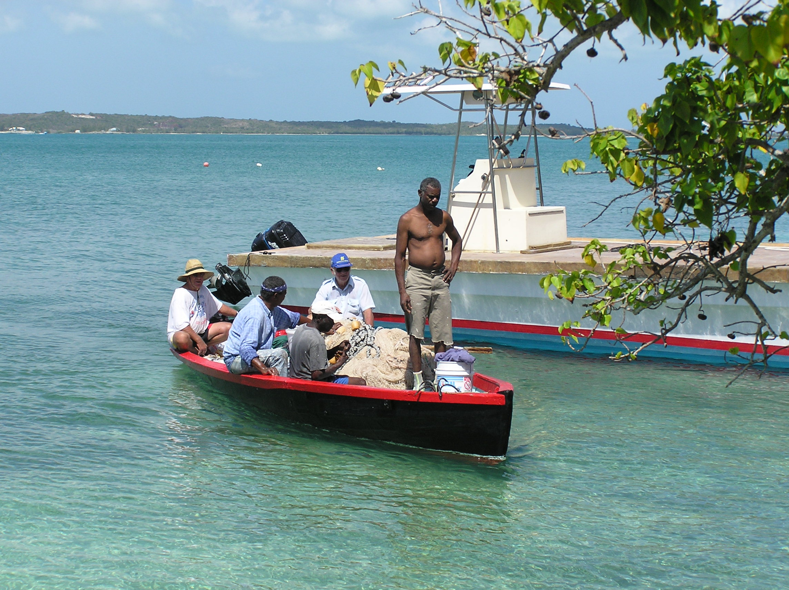

Pictured left to right: Captain Robbie Albury, Ralph Sawyer, Derek ‘Hitler’ Johnson, Jeremiah Neeley, Edward ‘Butchie’ Saunders Junior.

Robbie had bought the eighteen-foot-long hauling boat from Harry Sweeting in the early 1960s. Previously named the Cartilla, she was rechristened Black Dragon by her new captain because she was painted black with red trim. The hauling boat was custom built by John T Albury in the 1880s, with a low gunwale to allow the net to be pulled in with ease and the crew to climb back into the boat with speed. It was built at Harbour Island’s renowned shipyard (site of the popular fig tree on the front shore), where John T Albury also built the Sainte Marie, the Melrose and the Lady Shea. These three schooners were part of the great Harbour Island fleet that carried pineapples to Baltimore and the Eastern Seaboard, dragged lumber from Abaco or Jacksonville to Cuba or were sold to be used in the sponge or sisal industry.

In the early days, Captain Robbie could count on 800 runners or skip jacks in a single haul but by the turn of the century he knew he would have to be satisfied with 150; and then there were those dreaded days when not once did he spot a school of jacks skipping the water’s surface or even ‘wet the net’. The 150-foot-long seine net, made today with nylon fibre and plastic corks, was in the old days made of cotton with pond apple roots for floats. The corks kept the top of the net afloat while lead weights at the bottom of the net kept it vertical in the water. Over the years the depth of net grew from 6 feet, when the harbour teemed with fish, to 20 or 30 feet as the fish became scarce.

All hauls were made in the harbour. Some mornings the wily captain might head ‘down along’ to haul the banks or the rocks at Long Point, but on this morning he was bound ‘up along’ to Whale Point, where the current from Harbour’s Mouth drove many a rich bounty onto the banks of the harbour.

As the Black Dragon made its way up the harbour, with its glistening waters smooth as oil and the light of the sun creeping across the land, the crew watched intently for the ripple on the water or the gulls circling. The birds also searched for the fish beating the water as the jacks chased small fry up to the surface. Then comes the much-anticipated cry, “School ahead!” and the arm pointing in the direction of the skipping fish. The school sighted, Captain Robbie figures how the tide is flowing in order to set the net so as not to lose the school against the tide. He then skillfully circles the school.

Once in position, the first wingman is ordered overboard with one end of the rope, as the Black Dragon slowly encompasses the school. At regular intervals the remaining crew ease themselves over the low gunwale, taking the net with them, until all the net is passed out into the water. The last man, Captain Robbie, dives over with the other end of the rope and completes the circle. He drags the leads under his feet until the net is ready to pull and then he hurdles over the corks to trap the fish inside the net. He breaks the surface and shouts, “Pull hard!” With great effort, the net, heavy with fish, is hauled into the boat by the crew, who by now has scrambled back into the boat. If the school is as large as 500, Robbie ‘breaks the net’, closing the net halfway so as to pull half of the school safely into the boat, leaving the other half trapped to be pulled in later.

Occasionally, the crew will attempt what is known as a ‘blind haul’. They choose a favoured shoal and knowing where to throw the net over they usually pull in a mixed catch of yellow tails, yellow jacks, porgies, grunts, snappers, tangs and boxfish. Whatever the catch, they anchor the Black Dragon off a convenient beach, pick and thread some palmetto leaves (thatch palm) and tie the fish on the strings ready to be shared or sold. The share system is different in the various settlements but the tradition in Harbour Island is one-third to the person who owns the boat and the net, and the remaining two-thirds is shared among the crew. If the haul is small the share is equal between owner and crew.

In the early days when the hauls were plentiful, the Black Dragon approached the ramp at about mid-morning and announced its successful catch to potential customers by blowing the conch shell. People converged from all directions to buy a string of 5 or 6 fish for $1.50 (nowadays a string sells for $5). The hot, tired crew would take a welcome shower and breakfast before continuing the day as farmer, carpenter, painter or whatever their primary trade may be.

No one who has been on a haul can ever forget the hard work of dragging the leads or pulling the corks and the exhilaration of bringing the catch in.

I had the honour to be a first wingman in many a summer in Briland.

Kind Regards
Jim Lawlor
Jim Lawlor (Vice President and Corresponding Secretary)

