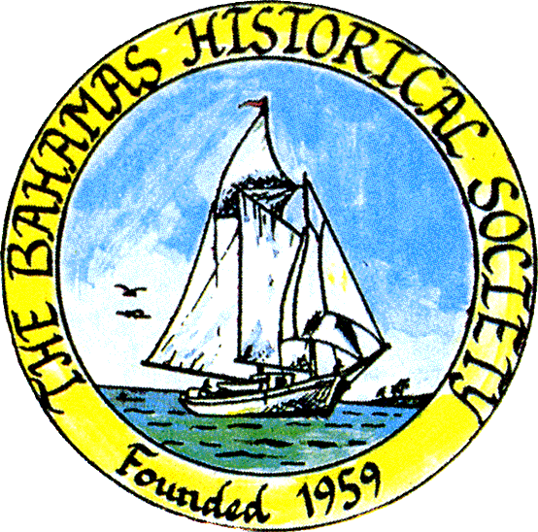
P. O. Box SS-6833
Nassau, N. P.
The Bahamas
 (242) 322-4231
email address: thebahamashistoricalsociety@gmail.com
Website: thebahamashistoricalsociety.org

/242HistoricalSociety
- BahamasHistSociety
Dear Members and Friends,

We are pleased to announce our next talk:

Thursday 25th April 2024 at 6.30 pm.

“The impact of the Governor General’s Youth Award on The Bahamas and Internationally”

Presenter: Jacquetta Maycock, National Director GGYA.

Place: The Bahamas Historical Society & Museum
Corner of Shirley Street & Elizabeth Avenue
Tel – 322-4231 or 424-3107

Parking kindly allowed by CIBC First Caribbean Bank Shirley Street.
Enter lot on Shirley Street.

Members and friends can also participate via Zoom:

Type zoom.com or click the link below to Join Zoom Meeting
https://us06web.zoom.us/j/83952739563?pwd=eThSSHNxTkVwaWExSGZOeWRuaytkdz09

Enter the following NEW credentials:
Meeting ID: 848 1805 0565
Passcode: 057038

OF INTEREST:

Over Easter we spent a wonderful few days in Long Island and visited all settlements from North to South.
We visited the Columbus Monument. (Image).

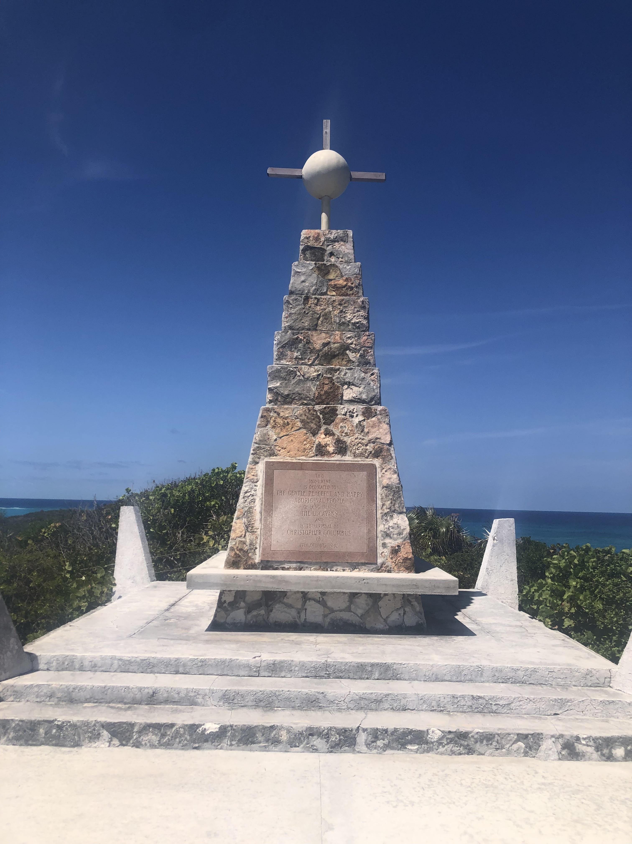

The Long Island brochure states that “The Monument to Columbus’ landfall is located at Long Bay, was so named for Columbus’ long boat which came ashore at that point. A monument placed on the floor of the ocean at Long Bay marks the exact spot where Columbus dropped anchor on 12th October 1492.

Of course, this information appears to be incorrect as Columbus’ journal indicates that:

At dawn on October 12th 1492, the natives of Guanihani awoke to see three strange objects to the East of their island.

Columbus stayed at San Salvador all day Friday and Saturday. And on Sunday afternoon he sailed for the island, which we now call Rum Cay and which he named Santa Maria de la Concepcion.
Thus, about midday on Tuesday he hoisted sail once more, and steered to the West for our Long Island which he named Fernandina. On Wednesday morning he went ashore at Long Island. (Wednesday would be the 17th October)

At dawn on Friday October 19th, exactly one week after landing at San Salvador, he weighed anchor and steered Southeast for an island which the Indians called Samoet and which he named Isabella and which we know as Crooked and Fortune Islands.

He was determined now to sail for a very large island to the South which the Indians called Cuba.

He was becalmed for the next two days, but set sail at midnight on Wednesday. At 3 p.m. the next afternoon they sighted the Ragged Island group of cays and followed them to the South.

And on Friday night, after two weeks in the Bahamas, he anchored on a bank to the South of these islands which is appropriately named Columbus Bank.

At sunrise the next morning he weighed anchor and set sail for Cuba - just about 30 miles to the South.

The 2023 Journal of The Bahamas Historical Society has an article “Re-examining Samuel Eliot Morison’s Thoughts on Columbus’s Inter-Island Route through The Bahamas by Donald L. McGuirk.

Image of Journey.

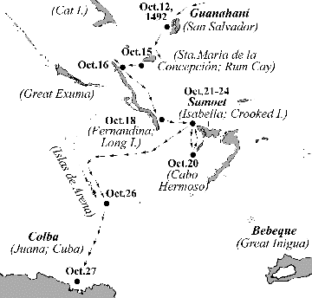

Kind Regards
Jim Lawlor
Jim Lawlor (Vice President and Corresponding Secretary)

