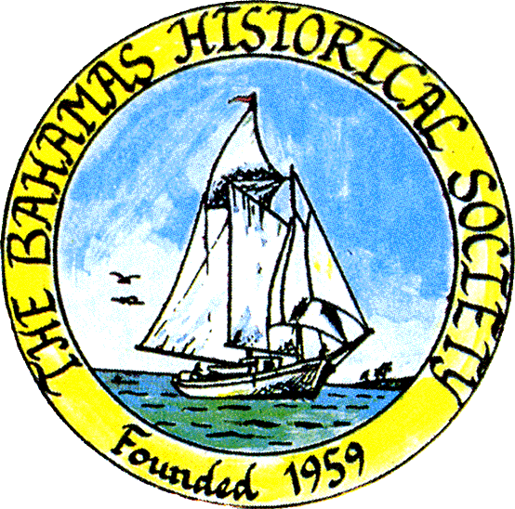
P. O. Box SS-6833
Nassau, N. P.
The Bahamas
 (242) 322-4231
email address: thebahamashistoricalsociety@gmail.com
Website: thebahamashistoricalsociety.org

/242HistoricalSociety
- BahamasHistSociety

Dear Members and Friends,

Upcoming talk:

Sunday 13th August 2023 at 4pm - Towards a History of Methodism in The Bahamas by Jim Lawlor.

At Rhodes Memorial Methodist Church, Montrose Avenue.

In June 2023, Rev. Carl Campbell asked me to assist in the writing of Methodist History in The Bahamas. I readily accepted as over the years I had been approached by the late Rev. Charles Sweeting to co-author such a history with him.

This talk contains ‘Towards’ in the title as there are gaps to fill and I am hoping to further research in the Department of Archives and that Methodist historians can add more detail.

The talk will cover the early Methodist history up to the early 20th Century with some insights into Methodism in New Providence, Eleuthera, Harbour Island, Abaco, Grand Bahama and individual churches in New Providence.

I have put together a fledgling book of that contains:

Contents of Towards a Methodist History of The Bahamas
Cover The Harbour Island Methodist Church
Preface
Chapter 1 Richard Moss: Disciple of John Wesley, First Missionary to Harbour Island, Bahamas.
Chapter 2 – The Early Methodist Contribution
Chapter 3 – The early life of the Harbour Island Methodist Chapel
Chapter 4 - The life and times of the Rev. John Turtle (1793 – 1825): Methodist Missionary to The Bahamas
Chapter 5 – Disestablishment and Disendowment of Anglican Church
Chapter 6 – Bahamian Methodists Protest
Chapter 7 – Methodist Men of Mark
Chapter 8 – The Methodist Church in Andros 1841 - 1986
Chapter 9 – Methodists in Abaco
Chapter 10 – Methodists in Grand Bahama
Chapter 11 – History of Ebenezer Methodist Church Nassau
Chapter 12 – History of Trinity Methodist Church Nassau
Chapter 13 – History of Coke Methodist Church Nassau
Chapter 14 – History of Curry Memorial Methodist Church, Nassau
Chapter 15 – History of Rhodes Memorial Methodist Church Nassau
Chapter 16 – St Michael’s Methodist Church Nassau

I can send a copy to interested persons as attachment to e-mail.

Of Interest:

Rules of the Society of the people called Methodists 1908, 1912 and 1913.
Forward Signed May 1, 1743 by John Wesley and Charles Wesley.

1 In the latter end of the year 1738, eight or ten persons came to me in London, who appeared deeply convinced of sin, and earnestly groaning for redemption. They desired (as did three or four the next day) that I would spend some time in prayer, and advise them how to flee from the wrath to come, which they saw as continually hanging over their heads. That we might have more time for this great work, I appointed a day when they all might come together; which, from thenceforward, they did every week; viz., on Thursday in the evening. To these, and to many more as desired to join with them (for their number increased daily). I gave those advices from time to time which I judged most needful to them; and we always concluded our meeting with prayer suited to their several necessities,
2 This was the rise of the UNITED SOCIETY, first in London, and then in other places. Such a Society is no other than ‘a company of men having the form, and seeking power, of godliness: united , in order to pray together, to receive the word of exhortation, and to watch over one another in love, that they each may help each other to work out their salvation.’
3 That it may the more easily be discerned whether they are indeed working out their own salvation, each Society is divided into smaller companies, called Classes, according to their respective places of abode. There are about twelve persons in every Class; one of whom is styled the Leader. Iy is his business, -
1 To see each person in his Class once a week at least. In order
To inquire how their souls prosper;
To advise, reprove, comfort or exhort, as occasion may require;
To receive what they are willing to give towards the support of the gospel;

2 To meet the Ministers and the Stewards of the Society, once a week in order
To inform the Minister of any that are sick, or of any that walk disorderly, and will not be reproved;
To pay the Stewards what they have received of their several Classes in the week preceding; And
To show their account of what each person has contributed. *

* The following are Mr Wesley’s own words relative to this subject. See Minutes of Conference at London 1782.
Q. 31. Have the weekly and quarterly contributions been duly made in all our Societies?
A. In many it has been shamefully neglected. To remedy this
1. Let every Assistant Superintendent remind every Society that was our original rule; Every Member contributes one penny weekly (unless in extreme poverty) and one shilling quarterly. Explain the reasonableness of this.
2. Let every Leader receive weekly contribution from each person in his Class;
3. Let the Assistant ask every person, at changing his ticket, ‘Can you afford to observe our rule?’ and receive what he is able to give.

4 There is only one condition previously required in those who desire admission into these Societies; viz., ‘a desire to flee from the wrath to come, to be saved from their sins.’ But wherever this is really fixed in the soul it wil be shown by its fruits. It is therefore expected of all who continue therein, that they should continue to evidence their desire of salvation.
First; By doing no harm, by avoiding evil every kind; especially that which is most generally practiced. Such is
The taking of the name of God in vain;
The profaning of the day of the Lord, either by doing ordinary work thereon, or by buying or selling;
Drunkenness; buying or selling spirituous liquor, unless in cases of extreme necessity;
Fighting, quarrelling, brawling; brother going to law with brother; returning evil for evil, or railing for railing; the using many words in buying or selling;
The buying or selling uncustomed goods;
The giving or taking of things on usury; i.e., unlawful interest;
Uncharitable or unprofitable conversation; particularly speaking evil of magistrates or of ministers;
Doing to others as they would not do to us;
Doing what is not for the glory of God; as the putting on of gold or costly apparel;
The taking such diversions as cannot be used in the name of the Lord Jesus;
The singing those songs, or reading books which do not tend to the knowledge or love of God;
Softness, and needless self-indulgence;
Laying up treasures on earth;
Borrowing without possibility of paying; or taking up goods without a probability of paying for them;

5. It is expected of all who continue in these Societies, they should continue to evidence their desire of salvation,
Secondly: By doing good; by being in every kind merciful after their power; as they have opportunity , doing good every possible sort, as far as possible, to all men.
To give their bodies, of the ability that God giveth, by giving food to the hungry, by clothing the naked, by visiting or helping them that are sick or in prison.
By doing good to them that are of the household of faith, or groaning so to be; employing them preferably to others, buying one of other; helping each other in business; and so much the more, because the world will love its own, and them only.
By all possible diligence and frugality, that the gospel be not blamed.
By running with patience the race that is set before them, denying themselves, and taking up their cross daily; submitting to bear the reproach of Christ; to be as the filth and off-scouring of the world; and looking that all men should say all manner of evil against them falsely, for the Lord’s sake.

6. It is expected of all who desire to continue in these Societies, that they should continue to desire their desire for salvation,
Thirdly, By attending upon all the ordinances of God; which are,
The public worship of God;
The ministry of the word, either read or expounded;
The Supper of the Lordl
Family and private prayer;
Searching the Scriptures; and
Fasting or abstinance,

7. These are the General Rules of our Societies; all of which we are taught of God to observe, even in His written word, the only rule, and the sufficient rule, both of our faith and practice. And all these these we know His Spirit writes on every truly awakened heart. If there be any among us who observe them not, who habitually break any of them let it be made known unto them who watch over that soul, as they must give an account. We will admonish him of the error of his ways; we will bear with him for a season. But if he repent not, he hath no more place among us. We have delivered our own souls.

Signed May 1, 1743 by John Wesley and Charles Wesley.

The 1912 Rules of the Society Statement:
In the Class meeting the fellowship of the Methodist people have found its most adequate expression.

2023 The Class System is said to be 'The DNA' of Methodism and for decades various 'forms' of groupings have emerged in attempts to revive the class system. Rev. Dr. Kevin Watson is one of the leading personalities diligently working on the revival of the class system at present.

ALSO

First English slave fort in Africa' uncovered on Ghana's coast
https://www.bbc.com/news/world-africa-66359512
The archaeologist is standing in the ruins of Fort Amsterdam, speaking above the wind and roar of the Atlantic Ocean waves hitting Ghana's coastline.
Inside that fort are what are thought to be the remains of an older fort - Kormantine - long-lost under the earth, which the professor's team are gradually excavating with brisk activity.

The first slaves Akan’Ashanti were brought to The Bahamas were from Fort Kormantine in 1721,

Kind Regards

Jim Lawlor

Jim Lawlor, Vice President and Corresponding Secretary.

