
P. O. Box SS-6833
Nassau, N. P.
The Bahamas
 (242) 322-4231
email address: thebahamashistoricalsociety@gmail.com
Website: thebahamashistoricalsociety.org

/242HistoricalSociety
- BahamasHistSociety
Dear Members and Friends,

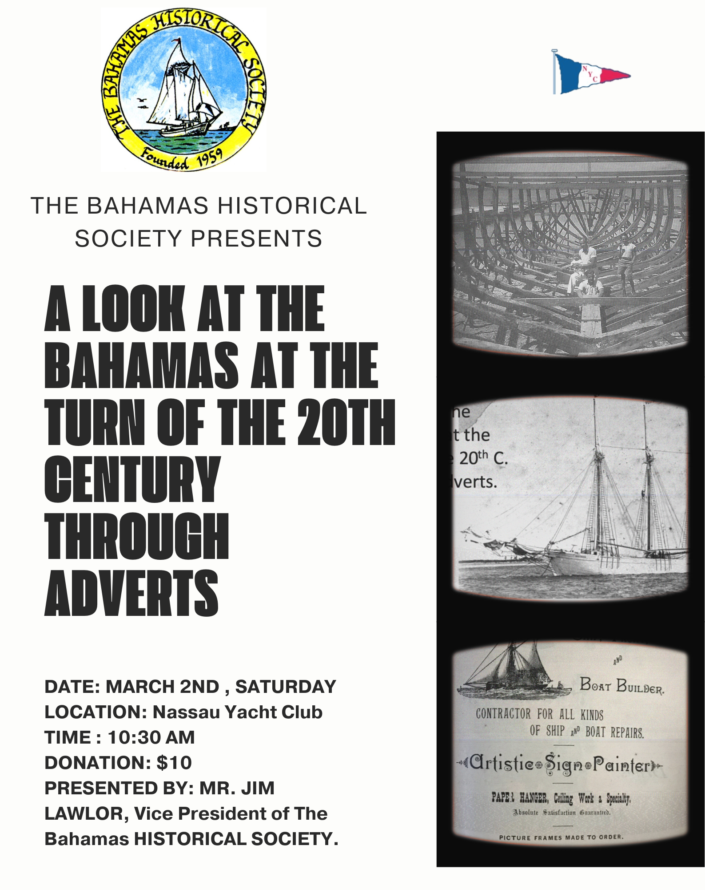
ZOOM invite:

Topic: BHS Jim Lawlor's Bahamas Adverts
Time: Mar 2, 2024 10:30 AM America East/Nassau

Join Zoom Meeting
https://univbah.zoom.us/j/96534811249

Meeting ID: 965 3481 1249
Passcode: Bahamas242

We are attempting to give our museum, which is in a 72-year-old building, a facelift. At a Management Committee Meeting on Saturday morning (10th February) we discussed what had been done and what was needed.
A new Air Conditioning system has been installed at a cost of over $7,000 and the lighting brought to full capacity.

Work that needs to be done:
Replace floorboards on stage and hall along with termite extermination.
The fans and vents need cleaned.
The outside walls need cleaned and maybe repainted.
The trees need to be cut back in the yard.
There are several areas of the roof tiles needing to be replaced and possibly the whole roof and some ceiling tiles replaced.
Outside water pipe replaced.
Repair or new kitchen sink.

Pressing needs:
A 15 foot ladder
A credit card machine as most tourists do not deal in cash (cost $160 per month)
A new printer.
Fire extinguishers refilled
More volunteers
MI FI Box from Alive to facilitate reliable zoom meetings.

We thank Andrew Saunders, Sheila Embleton and Donald Hopkins for their kind and most welcome donations and would be grateful for more donations.

A reminder that membership fees are due in January for 2024

Tentative date for Annual General Meeting Thursday 26th April.

Kind Regards
Jim Lawlor
Jim Lawlor (Vice President and Corresponding Secretary)

