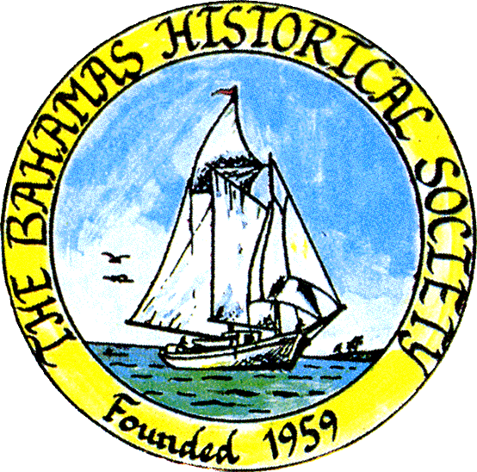
P. O. Box SS-6833
Nassau, N. P.
The Bahamas
 (242) 322-4231
email address: thebahamashistoricalsociety@gmail.com
Website: thebahamashistoricalsociety.org

/242HistoricalSociety
- BahamasHistSociety

Dear Members and Friends,

We apologise profusely about the decision to postpone the talk on Thursday 26th October but it has just come to our notice that there is a clash with another important event which many of our members may wish to attend:

Launch of the George Patrick Stewart Distinguished Lecture Series.
Thursday 26th October 2023 at 6.30 pm at the Baha Mar Convention Centre.
Speaker: Pericles Maillis “Memories of George Patrick Stewart”

Therefore, the new date for our next talk is as follows:

Thursday 2nd November 2023 at 6.15 pm – Dr Lisa Lawlor Feller will talk on:

The Maritime Highway Across the Lucayan Sea: Revisiting Bahamian History

There are a number of excellent reasons to name our sea The Lucayan Sea. The fact that it has remained nameless for over 500 years, the previous neglect of Bahamian tradition within a strong and growing tradition of Caribbean Study, the illicit trade that we would better trace if such a thing were named and mapped, celebrating maritime culture of The Bahamas, among many more. Perhaps the reason with the most impact is that we would finally be able to celebrate a lost Lucayan civilization that we remain separated from because of the European act of genocide after the initial 1492 landfall of Christopher Columbus. We would honour those who lived across these porous islands before us, while marking the spot where the Old World encountered an Ancient World resulting in a New World.

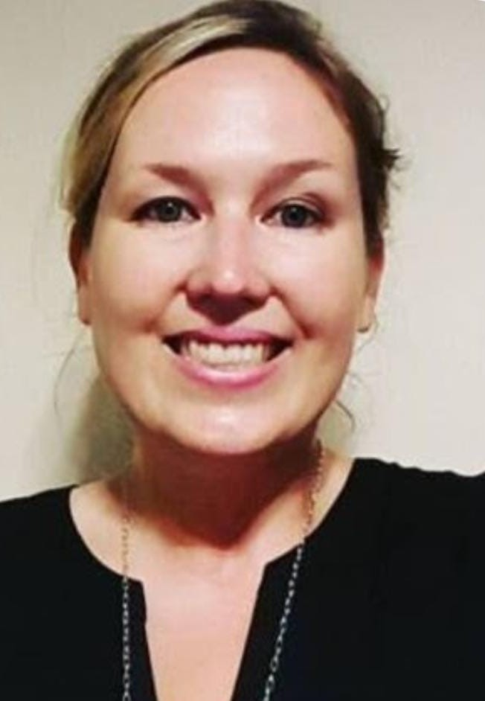

Dr. Lisa Lawlor Feller is an Assistant Professor of History at the University of The Bahamas, with a PhD in American Studies, specializing in Caribbean History. Her PhD dissertation is “Intersecting Frameworks through the Maritime Highway of The Bahamas: Re-mapping the Nassau Archive 1783-1834,” (2019) completed at the University at Buffalo. While Feller works to transform her dissertation to a book Wrecking to make a Reckoning, she has a number of ongoing creative projects. Lawlor Feller’s MA research paper also informs creative projects, and is titled “National Identity in The Bahamas: A Literary Perspective” (2011). Creative works include a children’s book on the Yoruba Goddess Yemaya, and a novel in place of a letter to her late mother, Anne Lawlor, in the tradition of Matria, looking at the strong tradition of Caribbean women writing nation.

Place: The Bahamas Historical Society & Museum
Corner of Shirley Street & Elizabeth Avenue
Tel – 322-4231 or 424-3107

Parking kindly allowed by CIBC First Caribbean Bank Shirley Street.
Enter lot on Shirley Street.

Members and friends can also participate via Zoom:

Type zoom.com or click the link below to Join Zoom Meeting
https://us06web.zoom.us/j/83952739563?pwd=eThSSHNxTkVwaWExSGZOeWRuaytkdz09

Enter the following NEW credentials:
Meeting ID: 848 1805 0565
Passcode: 057038
Kind Regards
Jim Lawlor
Jim Lawlor (Vice President and Corresponding Secretary)

