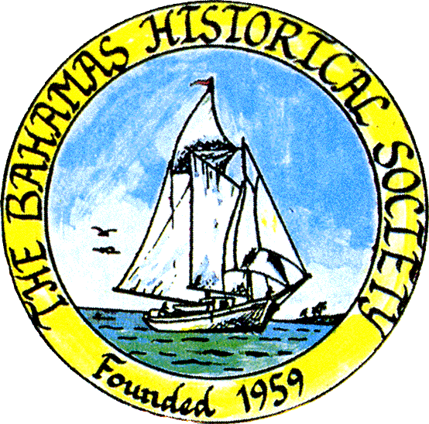
P. O. Box SS-6833
Nassau, N. P.
The Bahamas
 (242) 322-4231
email address: thebahamashistoricalsociety@gmail.com
Website: thebahamashistoricalsociety.org

/242HistoricalSociety
- BahamasHistSociety
Dear Members and Friends,

Call for Papers: 2023 Journal of The Bahamas Historical Society

The editorial board of the Journal of The Bahamas Historical Society is sending out a call for papers for the 2023 journal. The deadline for submission of articles has been extended to 30 September, 2023.
Following are the requirements for papers:
- The subject should be a historical topic on The Bahamas, bringing to light new information or a new interpretation of topics of Bahamian interest.
- Articles should be formatted using the Chicago style with end notes rather than footnotes.
- Articles should be 10 to 15 pages in length, with double spacing between lines and using a standard processing programme such as Microsoft Word.
- Photographs, maps, or other illustrations are welcome. Short communications, book reviews, public talks, and profiles of Bahamian personalities of less than 15 pages are also welcome.
- Articles are to be submitted by email to gsrt29@gmail.com .
- The Editorial Board has the right to edit articles submitted for publication.
- The Editorial Board has the right to reject an article submitted for publication. Decisions of the Editorial Board are final.
- Contributing authors will receive a complimentary copy of the journal volume in which their article is printed.

Grace Turner
Grace Turner, Editor

Please note that the museum will be closed for the month of August.

Kind Regards

Jim Lawlor

Jim Lawlor, Vice President and Corresponding Secretary.

