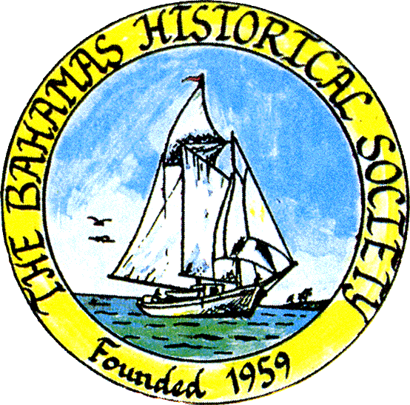
P. O. Box SS-6833
Nassau, N. P.
The Bahamas
 (242) 322-4231
email address: thebahamashistoricalsociety@gmail.com
Website: thebahamashistoricalsociety.org

/242HistoricalSociety
- BahamasHistSociety

Dear Members and Friends,

The Bahamas Historical Society mourn the death of our great historian, Dr Diane Gail Saunders OBE. Her loss is a great loss to The Bahamas and all who knew her.

Gail Saunders was editor of The Journal of The Bahamas Historical Society from 1982 until 2008. She was President of the Society 1988 to 1999 and under her leadership our museum was re-organized and improved. Gail gave frequent talks on the History of The Bahamas to our monthly presentations and wrote many articles for our journal. Every president from the early 1970s could count on Gail for advice and assistance from her vast store of knowledge and experience. She was also called on by other Caribbean countries to advise on the creation of their archives.

In an official statement posted on Twitter, Prime Minister Philip “Brave” Davis lamented the loss of Dr Saunders so close to the country’s 50th anniversary of independence. The prime minister also commended her tireless work in the preservation of Bahamian history.
“Gail Saunders was more than an accomplished historian, archivist, and author,” Mr Davis said. “She was a beacon of light, a repository of wisdom, and a resounding voice in preserving and narrating our national story. Her life’s work was dedicated to ensuring that our history was not just accurately recorded but made accessible and meaningful to us all.

In his statement of condolence, former Attorney General Sean McWeeney said that Dr Saunders revolutionised the field of Bahamian history and her work brought a never before seen spotlight to the topic of slavery in the Bahamas.
“The death of Dr Gail Saunders is a great loss for our nation. She was the pre-eminent Bahamian historian of her time, including the post-Independence era to date,” said Mr McWeeney. “Her ground-breaking academic research and writings about slavery in the Bahamas form an especially important part of her legacy. This was a subject which had been glossed over, even trivialized in some cases, by historians who came before her”.

Dr Ian Strachan wrote a beautiful tribute:

Today we have lost the single most accomplished and influential scholar The Bahamas has ever produced, Dr. Gail Saunders. For the 30 years I knew her, she was supremely humble, gentle, generous and open. She was never condescending or territorial. She shared her knowledge with anyone who showed an interest. The novel I will release this year, about the Crooked Island slave, Kate, would be impossible without the precious time I spent with her; she made the time to point me to old texts and give me precious advice. She didn't have to do that. She was a real inspiration and role model for me. And she was an institution builder. She devoted her life to our history and heritage. She is a national hero. Without her scholarship and commitment to archival preservation I certainly would not be the academic I am today or the informed citizen I am today. Best of all, Gail was a sweet, kind, peaceful, compassionate human being. She and her late husband, Winston Saunders, have left an amazing legacy as nation builders. I know what it means to be Bahamian because of people like Gail Saunders. She deserves a stamp, a street, a school and a statue. Most of all, her books deserve to be read by all Bahamians.

From Rev Carl Campbell:

I was saddened to hear today of the death of Dr. Gayle Saunders Her contribution to national development through the preservation of our history is commendable. We owe a deep gratitude of thanks for her vision and work on the national archives and the Bahamas Historical Society.

From Duke Wells

Dr. D. Gail Saunders, Ph.D, is a teacher, archivist, and the author of countless articles and twelve books that have clarified many aspects of Bahamian history.

As Director of Archives she supervised the establishment of the Pompey Museum and Balcony House Museum. She served as president of the Bahamas Historical Society and held various positions in archival and historical associations in the Caribbean and internationally.

She was involved in the restoration and development of the Villa Doyle - what is now The National Art Gallery of The Bahamas.

Excepts from The Editorial in the Nassau Daily Tribune of 3rd July stated:

The tributes to her were unstinting in their praise – but perhaps what was most striking was the number of people talking about what they had learned thanks to her. Not only was she important to people as a person, but Dr Saunders elevated the lives and knowledge of those around her.
Prime Minister Philip “Brave” Davis called her “a beacon of light, a repository of wisdom, and a resounding voice in preserving and narrating our national story”.

May those who follow her live up to the impact she has made on The Bahamas – and may she rest in peace.

Kind Regards

Jim Lawlor

Jim Lawlor, Vice president and Corresponding Secretary.

