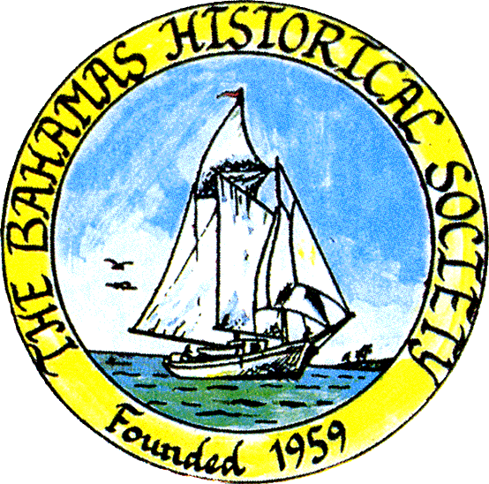
P. O. Box SS-6833
Nassau, N. P.
The Bahamas
 (242) 322-4231
email address: thebahamashistoricalsociety@gmail.com
Website: thebahamashistoricalsociety.org

/242HistoricalSociety
- BahamasHistSociety

Dear Members and Friends,

We are pleased to announce our June Talk – note the unusual day due to the travel schedule of our visiting American resident of Bahamian descent. He was a graduate of St Augustine’s College and Government High School.

Tuesday 20th June 2023 at 6.30 pm – Robert W Taylor

Calcareous Oolitic Limestone Rockland Soils of the Bahamas: Some Physical, Chemical, and Fertility Characteristics

Andros is considered the island in the Bahamas archipelago with the greatest potential for agriculture.
Robert W. Taylor has been the Dean and Director of Land-Grant Programs for the College of Agriculture and Food Sciences, at Florida A&M University, since 2012. Previously he served as
Dean of the School of Agricultural and Environmental Sciences at Alabama Agricultural and Mechanical University (AAMU) from 2006 to 2011, Professor of soil and environmental chemistry, and Director of the Center for Environmental Research and Training (CERT) from 1990 to 2006 at AAMU.

The meeting will be held in person at the Museum

Place: The Bahamas Historical Society & Museum
Corner of Shirley Street & Elizabeth Avenue
Tel – 322-4231 or 424-3107

Parking kindly allowed by CIBC First Caribbean Bank Shirley Street.
Enter lot on Shirley Street.

Members and friends can also participate via Zoom:

Type zoom.com or click the link below to Join Zoom Meeting
https://us06web.zoom.us/j/83952739563?pwd=eThSSHNxTkVwaWExSGZOeWRuaytkdz09

Enter the following credentials:
Meeting ID: 839 5273 9563
Passcode: 901917

OF INTEREST: Lighthouses

The 12 "Major" Bahamian Lighthouses
1. The Hog (Paradise) Island Lighthouse was constructed in 1817. It is a 19 m (63 ft) round old-style brick tower with lantern and gallery, painted white; lantern painted red. This is the oldest lighthouse in The Bahamas and the oldest surviving lighthouse in the West Indies. The lighthouse is located at the western end of Paradise Island (formerly Hog Island) marking the northwest entrance to Nassau Harbor. The Hog Island Light was automated in 1958. It is not a part of the ILS lighthouses.
2. Hole-in-the-Wall Lighthouse was erected in 1836 and is still active today. The name “Hole-in-the-Wall” referred to a limestone arch at land’s end near the lighthouse. This lighthouse is one of the best examples of old-style British lighthouse architecture in the New World. It is not the first lighthouse built in the country, but it was the first to be built in The Bahamas by the Imperial Lighthouse Service. As late as 1995, it was still fuelled by kerosene and lit every night by resident keepers. The lighthouse was automated in 1995.
3. The Gun Cay Lighthouse was constructed in 1836. It is a 15 m (50 ft) round old-style stone tower surmounted by a short square pyramidal skeletal tower; upper half of tower painted bright red, lower half white. Two 1-story keeper's houses are abandoned and falling into ruins. The original lantern was transferred to Elbow Cay in 1936. The lighthouse is located at the south end of the cay, one of the smaller islands less than 10 miles south of Bimini. It is accessible only by boat.
4. The Cay Sal lighthouse is located on Elbow Cay, at the western end of the Cay Sal Bank about 80 km (50 miles) off the Cuban coast and 130 km (80 mi) southeast of Key West, Florida. The lighthouse was constructed in 1839 and marked the southern entrance to the Florida Straits from the Gulf of Mexico.
5. The Great Isaac Lighthouse is located at the northern end of the Bimini archipelago. It was erected in 1859. It has a 46 m (151 ft) round cast iron tower with lantern and gallery, painted white.
6. The Great Stirrup Cay Lighthouse is located at the Northern end of the Berry Islands. It was erected in 1863 and is still active today. The lighthouse is a 17 m (56 ft) round stone or brick tower with lantern and gallery, painted white.
7. The Elbow Reef Lighthouse, located on Elbow Cay, west of the harbour at Hope Town, Abaco, was erected in 1864 and is still active today. The tower is 89 feet high and there are 101 steps up to the lantern room. It emits five white flashes every 15 seconds at 120 feet above sea level, with a visibility of 15 nautical miles. It is equipped with a revolving first order Fresnel lens, round masonry, with lantern and gallery. The lighthouse is painted with horizontal red and white bands while the lantern is painted with a grey metallic dome. This is probably the most visited lighthouse in The Bahamas.
8. The Castle Island Lighthouse is located off the southwest tip of Acklins Island. The lighthouse was constructed in 1868. It has a first order Fresnel lens a 34 m (112 ft) round brick tower with lantern and gallery, painted white.
9. The lighthouse at Cay Lobos was constructed in 1869. Its round cast iron tower stands at 45 m (148 ft), with lantern and gallery, painted white. The tiny cay is, a famous hazard to navigation, is located in the Old Bahama Channel only 50 kilometers (30 miles) off the north coast of Cuba, but it is owned by The Bahamas. The lighthouse was ordered by the British colonial authorities and completed in 1869. For lighthouse keepers, it was the most isolated posting in The Bahamas. Today the light is automated and solar powered.
10. The lighthouse at Inagua is located at the south-western tip of Great Inagua near Matthew Town. It was constructed in 1870. It is a round masonry tower that stands at 34 m (112 ft) with lantern and gallery painted white. This lighthouse was recently automated.
11. The Bird Rock Lighthouse, Crooked Island, was constructed in 1876. It has a 30.5 m (100 ft) round tower with lantern and gallery, painted white.
12. The San Salvador Island Lighthouse is located at Dixon Hill, San Salvador, which is the highest point on the island at the north-eastern side of the island. It was erected in 1887 and is still active today. It is a 22 m (72 ft) round tapered brick tower with lantern and gallery, painted white.

The Bahamas in International Intrigue: Lighthouses and Cay Sal by Jim Lawlor Link
file:///C:/Users/james/Downloads/supervisor,+2018JL+FINAL.pdf

Also

Unraveling the Secrets of the Long-Lost Shipwrecks in the Bahamas
Using historical records, a new initiative has identified and mapped 176 wrecks in the region
https://www.smithsonianmag.com/smart-news/shipwrecks-bahamas-research-map-180982314/?utm_source=smithsoniandaily&utm_medium=email&utm_campaign=editorial&spMailingID=48380602&spUserID=NjI3MDMwOTM3NjA4S0&spJobID=2480856159&spReportId=MjQ4MDg1NjE1OQS2

Is this why we love Junkanoo? How rhythm shapes our lives

https://www.bbc.com/future/article/20230526-how-rhythm-shapes-our-lives

A note about our website: The first link shown on Google Search leads to a circling blue loop but the other hits below that “Our History” opens the website.

Kind Regards
Jim Lawlor
Jim Lawlor (Vice President and Corresponding Secretary)

