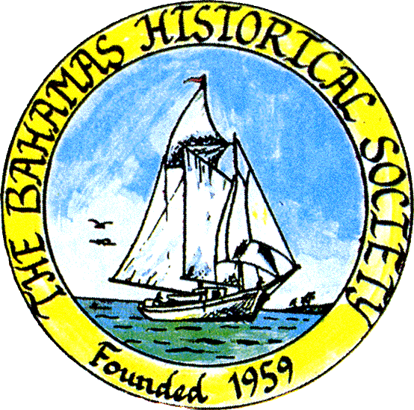
P. O. Box SS-6833
Nassau, N. P.
The Bahamas
 (242) 322-4231
email address: thebahamashistoricalsociety@gmail.com
Website: thebahamashistoricalsociety.org

/242HistoricalSociety
- BahamasHistSociety

Dear Members and Friends,

We express our apologies for the failure of the zoom presentations for our last two talks due to technical errors beyond our control. But we will try again for our next talk:

Thursday 20th April at 6.15 pm

Christopher Davis will launch his book entitled Black Rinse.

Black Rinse delves into the origins of Junkanoo - a festival more profound in The Bahamas than anywhere else in the world - but is still practised in Ghana and other countries where Africans in the Diaspora live today.

The book will be on sale and Christopher will sign copies.

The meeting will be held in person at the Museum

Place: The Bahamas Historical Society & Museum
Corner of Shirley Street & Elizabeth Avenue
Tel – 322-4231 or 424-3107

Parking kindly allowed by CIBC First Caribbean Bank Shirley Street.
Enter lot on Shirley Street.

Members and friends can also participate via Zoom:

Type zoom.com or click the link below to Join Zoom Meeting
https://us06web.zoom.us/j/83952739563?pwd=eThSSHNxTkVwaWExSGZOeWRuaytkdz09

Enter the following credentials:
Meeting ID: 839 5273 9563
Passcode: 901917

To view our previous talk please watch on YouTube:

Scott Johnson’s on: Wild Bahamas: A look at the Prehistoric Fauna of The Bahamas with Special Focus on the Bahamian Giant Barn Owl.
Link https://www.youtube.com/watch?v=IEzOeNEp674

OF INTEREST:

Since March is Women’s History Month, I would like to share these notes on Yoruba women.

The Yoruba community is mainly in the Southwestern part of Nigeria, some parts of Kwara, Benin and Delta and some parts of Togo, Brazil, Cuba and Republic of Benin. The language of the people is Yoruba language, but there are different dialects of the language from different parts of Yoruba land. The culture, beliefs and thoughts of the Yoruba people are entrenched in their language, songs, food and religion.

The traditional Yoruba concept of gender is actually perdurantist in nature. It is important to note, at this point that, just as the traditional western concept of gender is patriarchal in nature, the traditional Yoruba culture is also patriarchal in nature.

(Perdurantism or perdurance theory is a philosophical theory of persistence and identity)

It is widely known (but not systematically documented to date) that individuals and groups of women among the Yoruba-speaking peoples of Nigeria, historically maintained positions of great cultural power. They held these positions not only in the domestic arena, but in economics, trade, politics, religion and other social domains as well.

Yoruba power was gradually weakened by the encroachments of Islam, Christianity (especially the Pentecostal or "born-again" sects), colonialism, and modernism. The result was (and still remains) a generally unbalanced and distorted view of the constituent categories of power possessed by Yoruba women.

The Yoruba identifies a woman as a whole entity, entirely different from a man. Hence, while the English language suggests that a woman is a product of man - (wo)man, Yoruba language, identifies a female person (obirin) as a distinct kind of person. Thus, for the Yoruba, Obinrin is not etymologically derived from Okunrin (Oyewunmi, 1997). The traditional Yoruba concept of gender considers a woman, a whole human on her own, a subset of human beings and not a subset of a man. Another evidence is that boundary of gender construction in Yoruba culture shifts depending on age, status and wealth (Olajubu, 2003). Hence, the female person does not persist consistently as inferior prototype of the male person. While a female person may persist as an inferior prototype of the male person, at time T1 , the same female person may persist as equal or superior to her male peers at time T2 , depending on her age, wealth and status.

For example, a female person that becomes a regent or a warrior in a traditional Yoruba setting is superior to other male persons, including her husband if she has one. For example, one can consider the case of Moremi Ajasoro, a Queen and Heroine in Yoruba land, who is reported to have led the liberation of her people, Ife people, from a neighboring town terrorizing them (Ojetayo, 2015). Another example is Efunsetan Aniwura, the second Iyalode of Ibadan, who was a successful merchant and trader, and wielded unusual political, military, religious and economic powers in the 19th century. She is considered one of the most powerful women in Africa (Ilesanmi, 2014). A third evidence lies in how the woman is eulogized in the traditional Yoruba culture. For example, a mother is considered a deity, which is honoured by all (Makinde, 2004). Motherhood is considered an esteemed position in Yoruba land. The type of honour conferred on motherhood in Yoruba land is much higher than the mothers- day celebrations in the west. Yoruba culture believes a mother has some power and the success of her children lies in her hands. It is believed that when a mother is good and her child does not reciprocate the love, the child will experience some sort of misfortune at one point or the other or attract some sort of curses unto himself or herself. Yoruba culture believes there are some God-given powers invested in a woman and those powers are sacred. For example, Olatunde argues that, The women in the Yoruba world view appear as 'water' (reminding us of the primordial water) and as 'bird' (pointing up the primordial hen or pigeon).

In the Yoruba life style, the home belongs to men whereas the women principally control the market
Yoruba women occupied a significant place in precolonial political organization, religion, family life and the economy… Nineteenth century accounts and oral records reveal that Nigerian women actively participated in the social, economic and political development of their societies. Yoruba women played significant roles within their families and communities. They occupied a pivotal place in the local and state economy – organizing household industries, operating the local market system, and establishing long long-distance trade networks. In the political arena, traditions recall that women founded kingdoms and communities, occasionally wielded political offices, acted as regents, sat on the King’s councils, held political offices, intrigued in palace politics, helped to make and unmake kings, served as go-betweens in diplomatic relations, and safeguarded their towns when their menfolk waged war elsewhere. They conducted key rituals to maintain the spiritual well-being of kings and kingdoms as well as of their own families and communities.

Women did not adopt their husbands family name when they marry. The history of women adopting their husbands name is rooted in the belief that the woman is a property.

In Eastern Yoruba society, many towns have Kings and Queens that are not married to each other. This was a situation in which the affairs of men were managed by the King, while the affairs of women were managed by the Queen; however, where there is a community wide or town wide matter, both King and Queen, with their Chiefs and other leaders will come together to resolve such matters.

In the precolonial Yoruba culture, a woman was not considered predominantly weak, inferior, docile, meek or subservient. A woman was characterized as different being at different phases of their lives. As a daughter, she has a major role in her father’s family, especially when she is the first daughter. As a wife, she has a major role and as a mother too. She could maximize her full potentials in all these roles, just as a man could do the same.
The role of a woman in the precolonial era was complementary to that of a man; the woman was not subservient. Women were as enterprising as men; they were not socially and economically disadvantaged. This is further accentuated to by Denzer who asserts that, Yoruba women had important legal rights in their natal homes. These included access to land, the use of their fathers’ houses, a share in the profits from their fathers’ farms, and participation in the ancestral and orisa cults of their paternal lineage. Thus, women possessed independent sources of ritual, economic, and political influence. They could count on their father’s people for financial assistance in their trading ventures as well as protection in cases of marital discord. Such rights extended to their children, ensuring their children protection and refuge should conflict or trouble threaten their security in their mother’s husband home. Tradition, eyewitness accounts, and official records contain many examples of exiled rulers or rival contenders for power seeking protection and support from their mother’s people.

Further reading:

Olajubu, Oyeronke (2003). Women in the Yoruba Religious Sphere. Albany: State University of New York Press.

Olatunde, Lawuyi (1988). “The Reality and Meaning of Being a Woman in the Yoruba Cosmogonic Myths.

Oyewunmi, Oyeronke (1997). The Reinvention of Women: Making an African Sense of Western Gender Discourses. Minneapolis: University of Minnesota Press.

Spelman, Elizabeth (1988). Inessential Woman: Problems of Exclusion in Feminist Thought. Massachusetts: Beacon Press.

Future Plans:
Thursday 27th April at 6.15 pm Annual General Meeting.
We also are in the early stages of planning a Lunch and Fashion Show to be held sometime in May or early June.
Kind Regards
Jim Lawlor
Jim Lawlor (Vice President and Corresponding Secretary)

