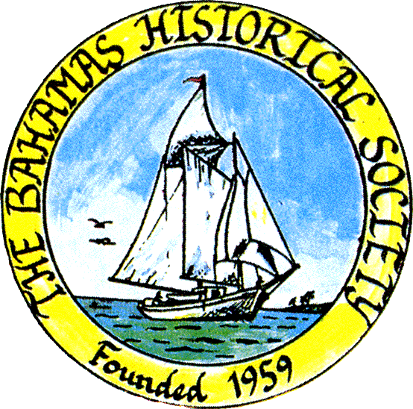
P. O. Box SS-6833
Nassau, N. P.
The Bahamas
 (242) 322-4231
e-mail: info@bahamashistoricalsociety.com
http://www.bahamashistoricalsociety.com

/242HistoricalSociety
BahamasHistSociety

Dear Members and Friends

To all interested persons

It is planned to have a meeting on Saturday 24th August 2019 at 11 am at the museums to discuss plans for events and proceedings during our 60th year since the founding of the Society in 1959.

We hope you can attend this important meeting.

Kind regards Jim Corresponding Secretary

